 

**PROJECT REPORT**

|  |  |
| --- | --- |
| Project Name | Cloud Kitchen |
| Project Title | GrubKing |
| Project by | Aptech Qatar Warriors |



GrubKing

Index

Table of Contents

Acknowledgement 2

Project Synopsis 3

Proposed Solution 4

Site Map 5

USER GUIDE 6

User Login Portal 6

Homepage 9

Menu Page 13

About Us Page 16

Contact Page 18

Developer Guide 20

Source Code 21

HTML 21

CCS 39

JavaScript 52

Acknowledgement

In performing this project, we had to take the help and guidelines of some respected persons, who deserve our greatest gratitude. The completion of this assignment gives us much pleasure.

We would like to show our gratitude to **Mr. Jaspal Singh** for giving us good guidelines for the project throughout numerous consultations.

We are also thankful to Aptech Faculty Management for encouraging us in the execution of this project.

* Aptech Qatar Warriors

Project Synopsis

Eating home-cooked food can sometimes be a luxury or even a time-consuming chore considering the amount of preparation it can take. If one is exhausted after a difficult day’s work or one is sick and unable to cook, ordering food online can be a good alternative. Perhaps, a group of people are suddenly visiting your home and there is no time or no available ingredients to cook an elaborate meal quickly for so many persons. Ordering online would be an easy way out here. Besides these, there are various other circumstances where it makes sense to order food online than cook at home. As per a recent study conducted abroad, there could be a scenario where by 2030 most meals currently cooked at home are instead ordered online and delivered from either restaurants or central kitchens. When restaurants and kitchens partner with online services to form a collaboration, such services are called as cloud kitchens.

Scope

This Web portal must be a responsive and visually appealing Website to be used by individuals. This portal must be designed to enable users to browse through and select food items to be delivered.

Proposed Solution

The proposed Website for online food ordering is titled GrubKing and its purpose is to enable people to browse through restaurant menus online and order food online.

GrubKing consists of four main pages.

1. Home
2. Menu
3. About
4. Contact

Site Map

USER GUIDE

User Login Portal

As soon as you open the site, you’ll be asked to enter your name. You can either choose to enter your name or simply close the login modal box.

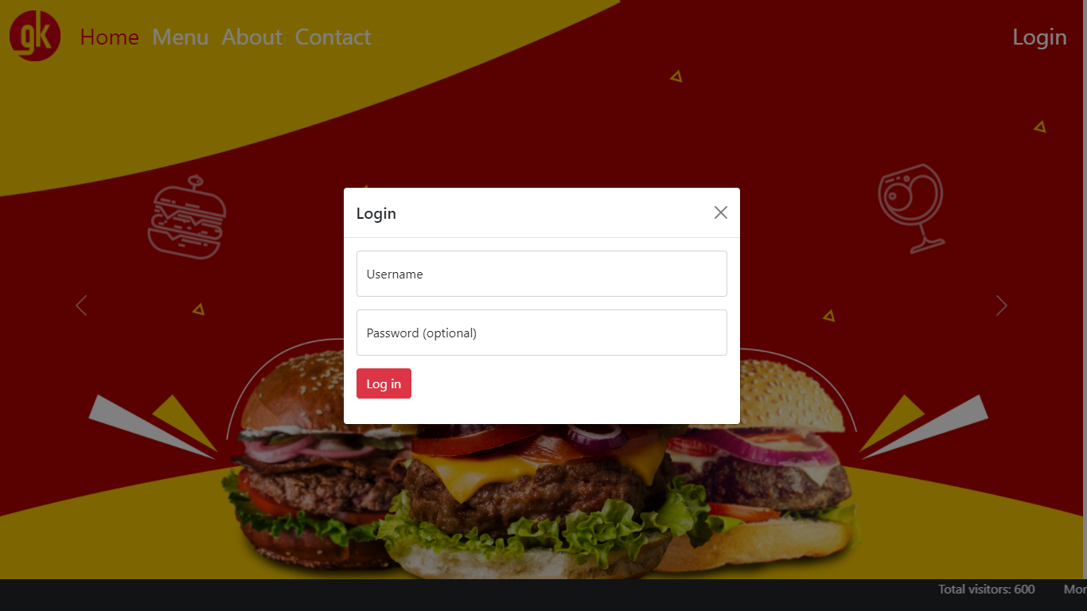



Welcome Message  
If you choose to login, you’ll welcomed with this message.

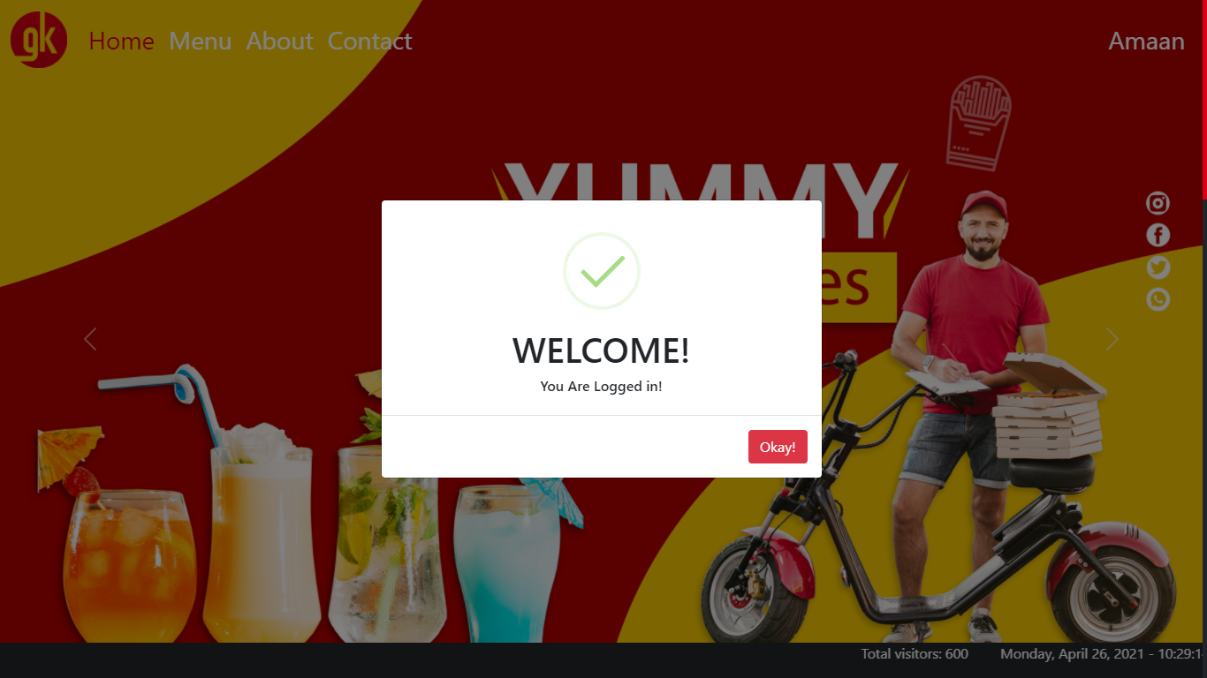



If a user wish to logout, they can simply click on their name, and select the logout option.

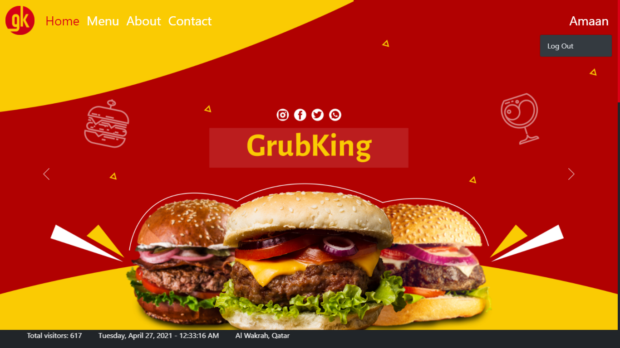



Homepage

Hero Section

Here, users will be asked to share their location, if enabled it, their current location should be displayed at the bottom of the screen.

That feature is called the Scrolling Ticker, which we will see later in the development chapter.

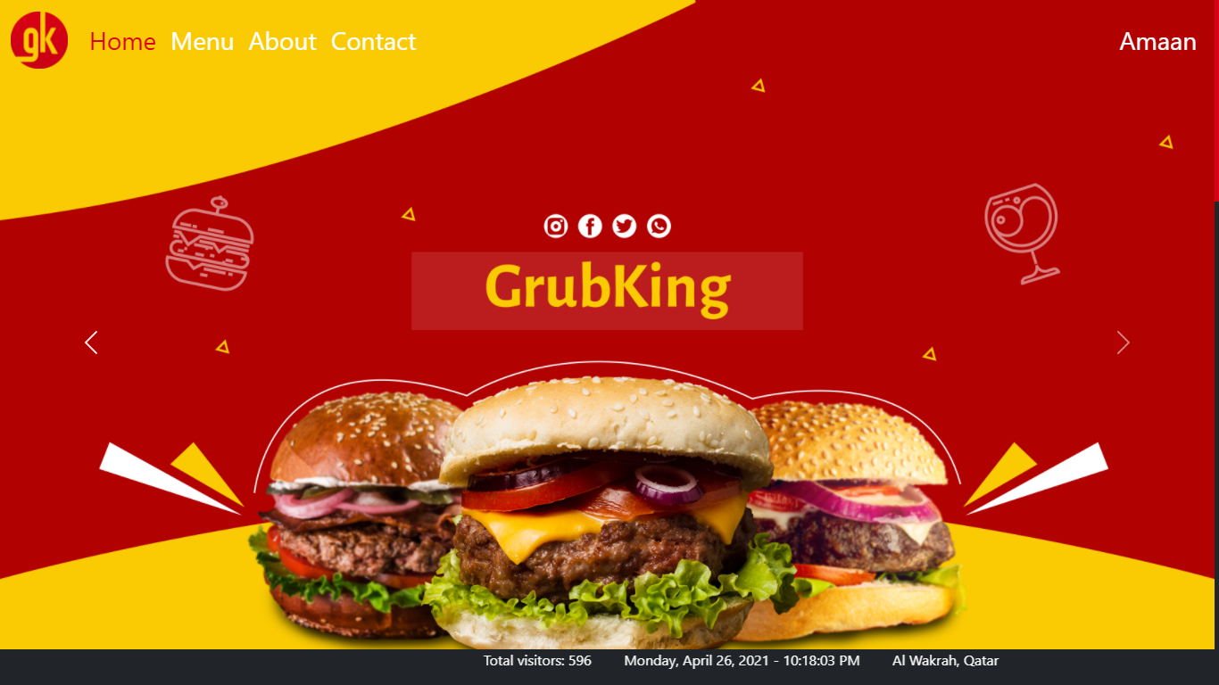



On scroll, the navigation bar’s background color changes to white on desktop or any large screen.

On mobile and other small screens, it’s by default white.

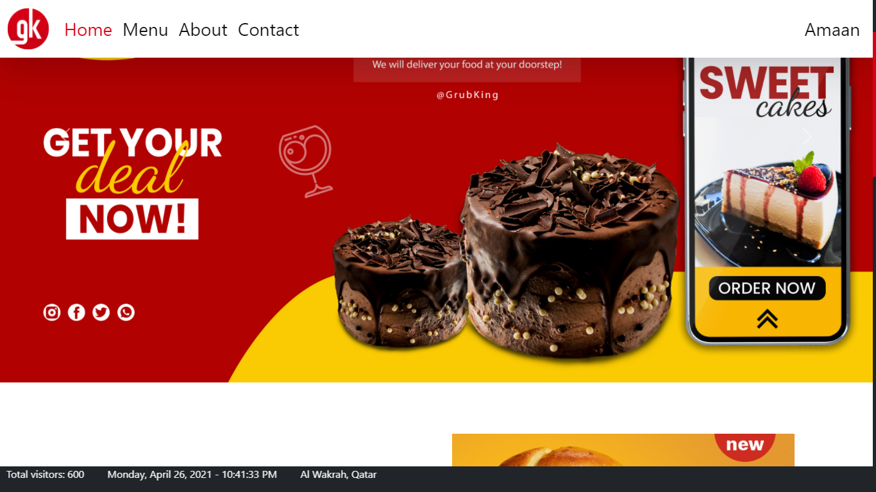



Homepage Contents

The homepage features popular food items and on-going sales on restaurants.

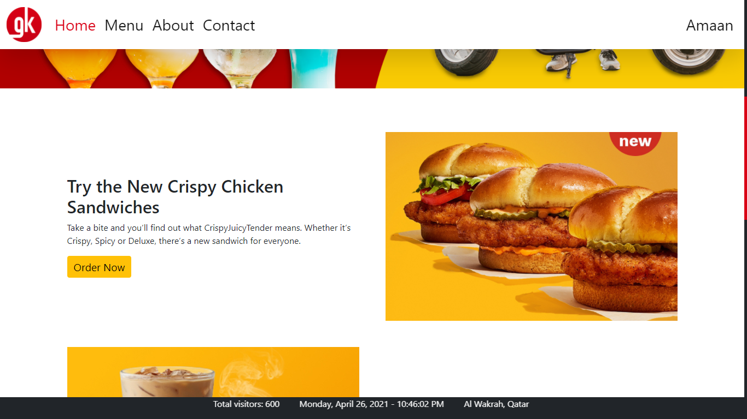

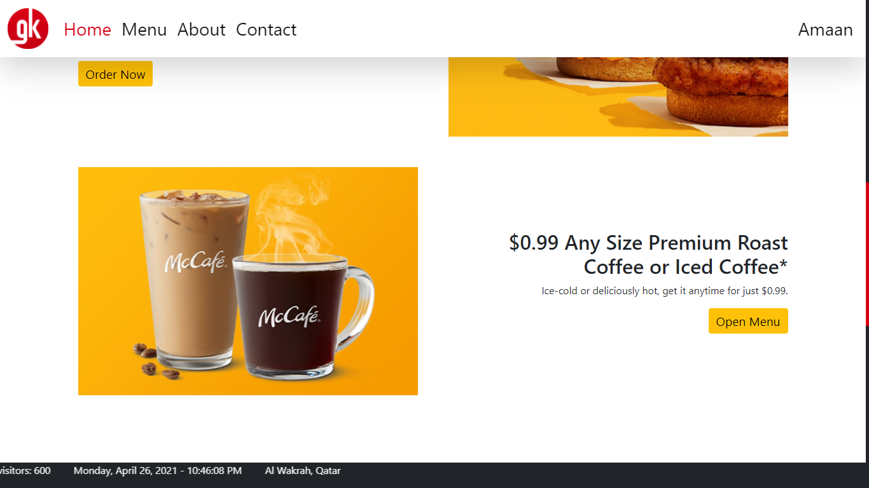

It also features other promotional advertisements.

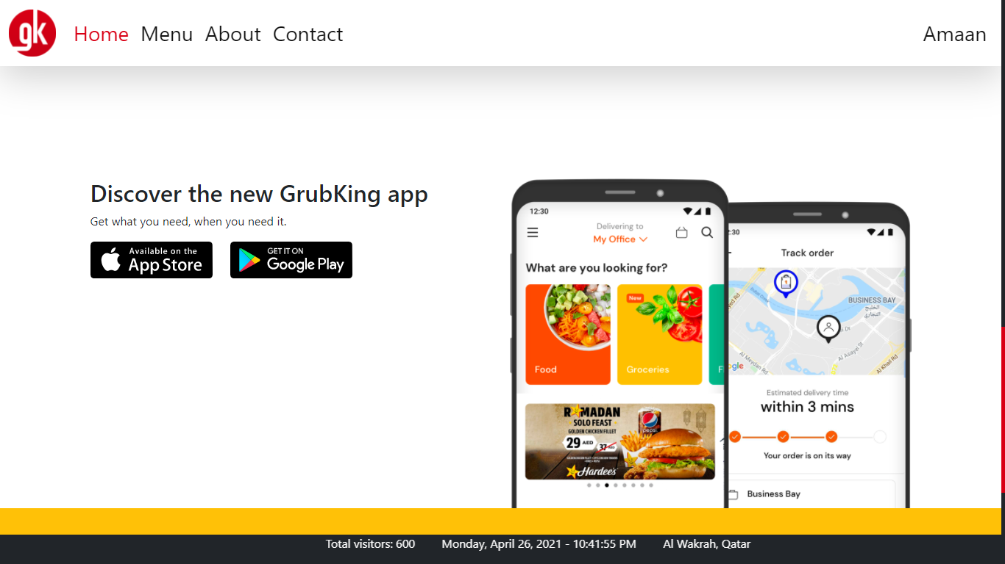

And at the end, there’s a page footer displaying the site logo, name and links to its social media accounts.

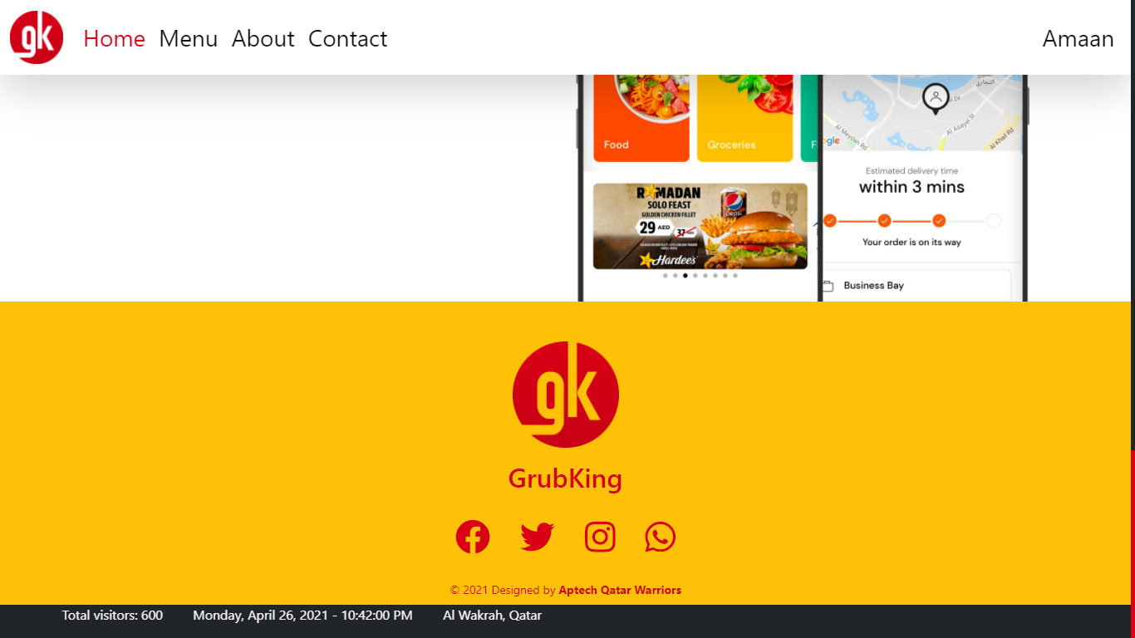

Menu Page

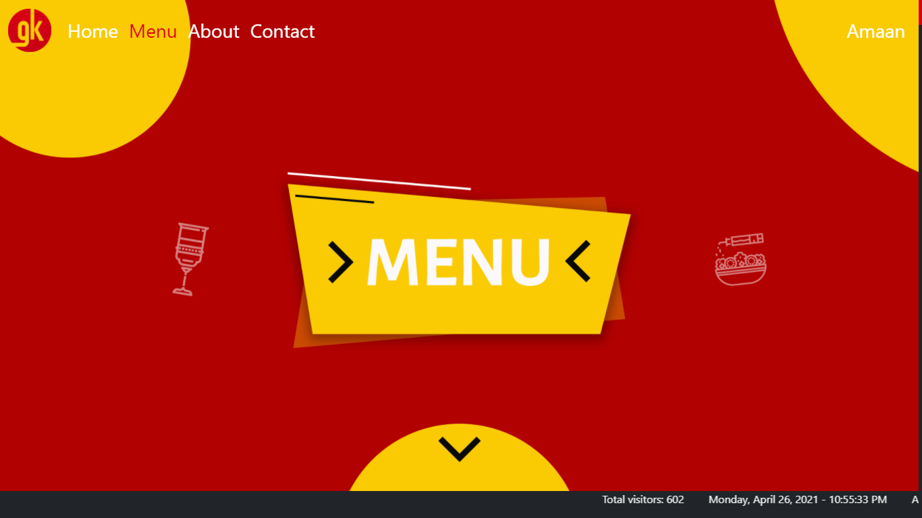

On scroll, a search bar and a list of restaurants by their logo are displayed.

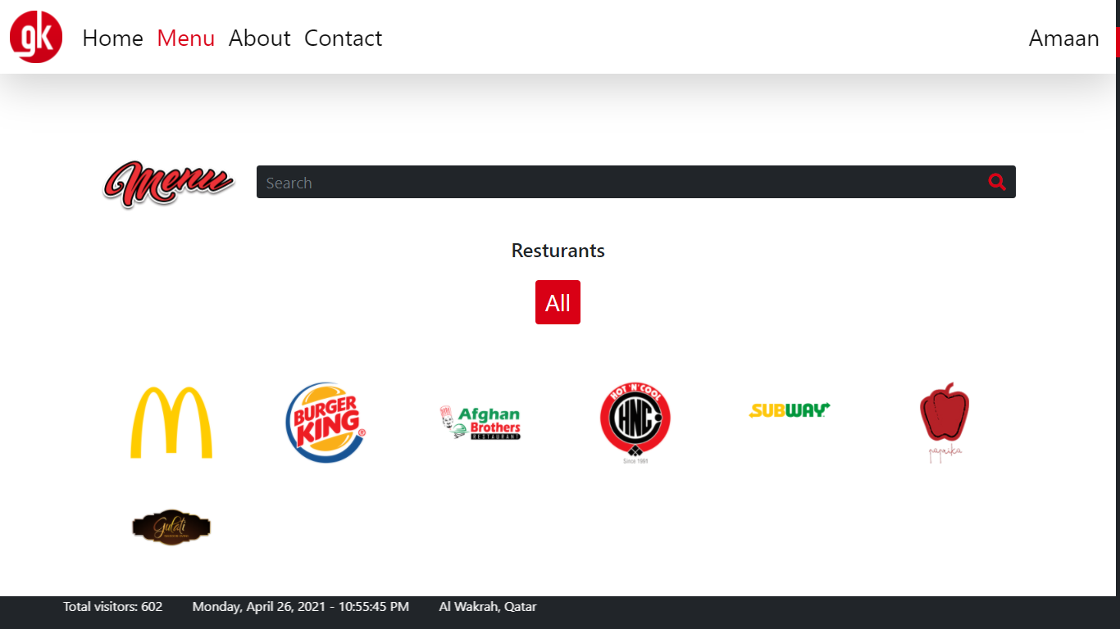

Users can find food items and filter categories below the search bar and list of restaurants.

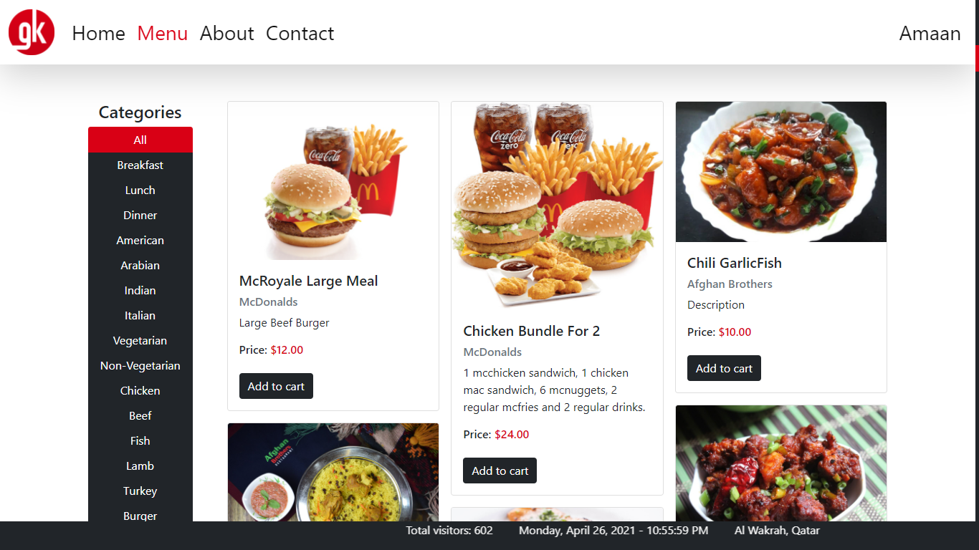

And filter the items using the categories panel of the left.

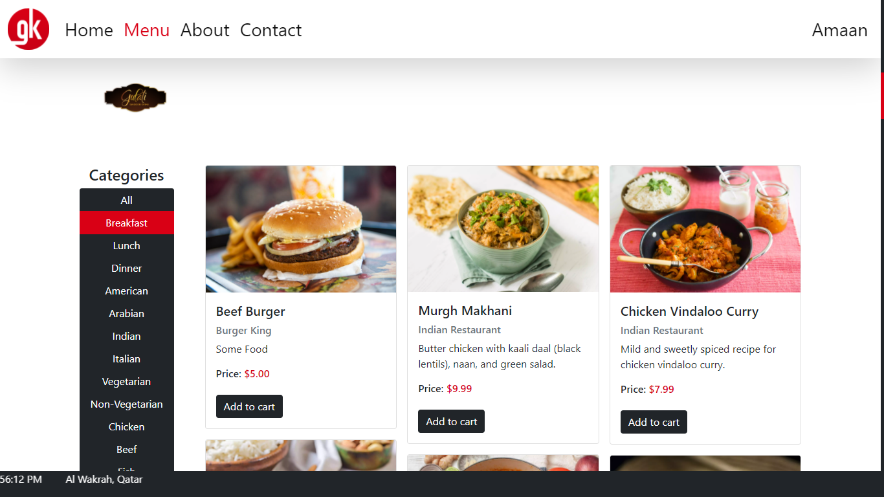

They can also filter the items by their restaurant.

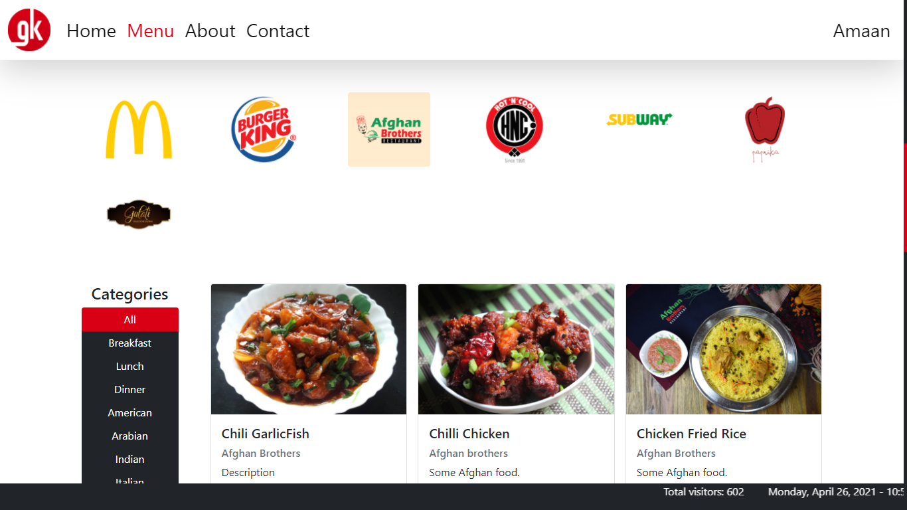

Or simply for a specific item.

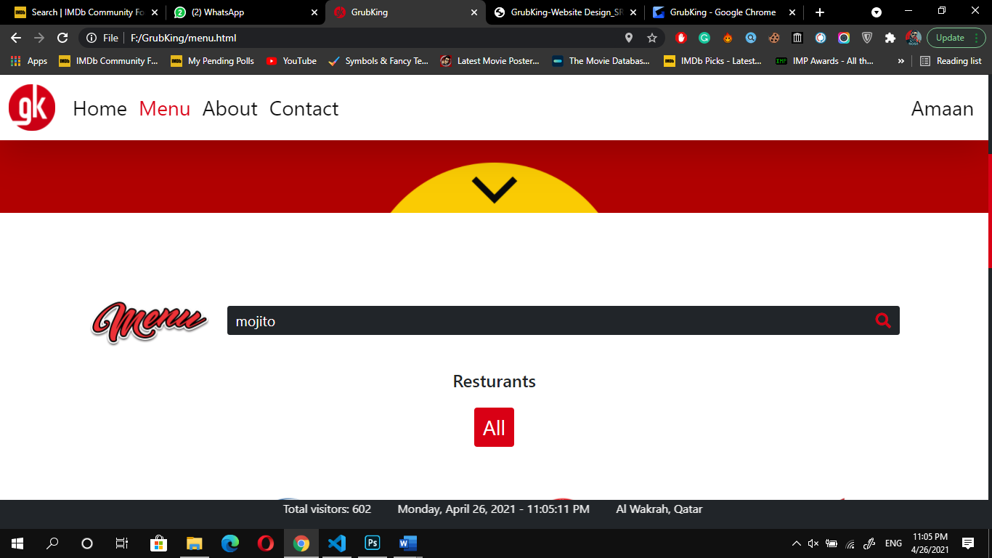

About Us Page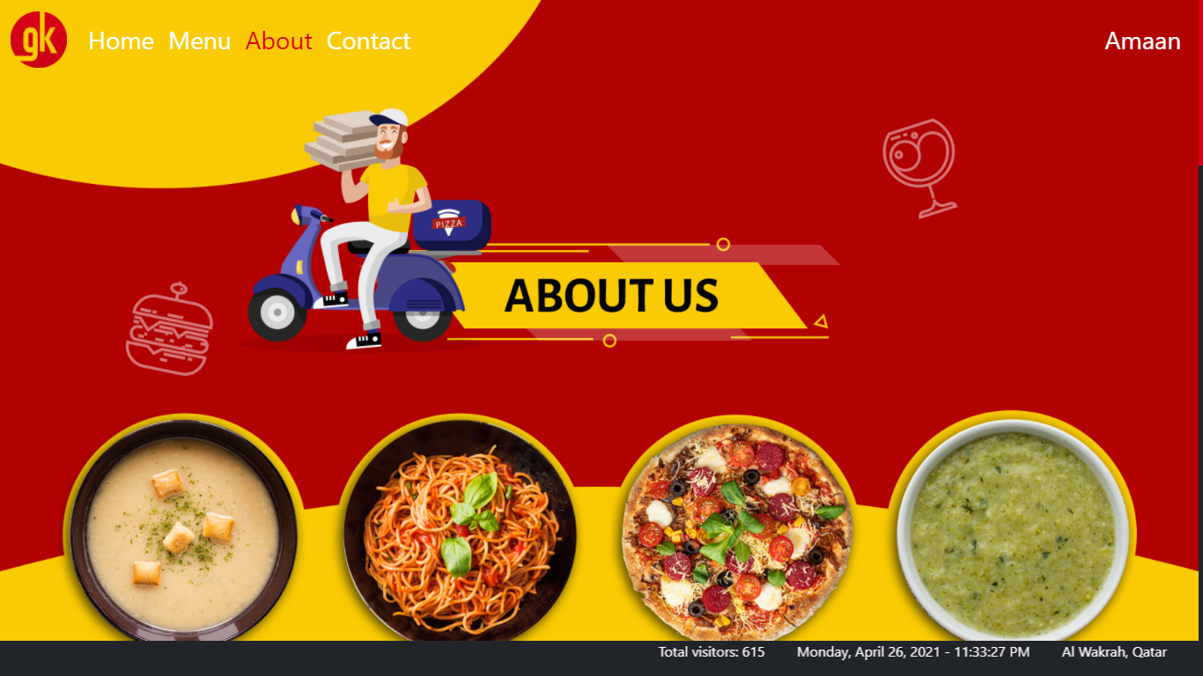

Find out about us and know some of the facts about us.

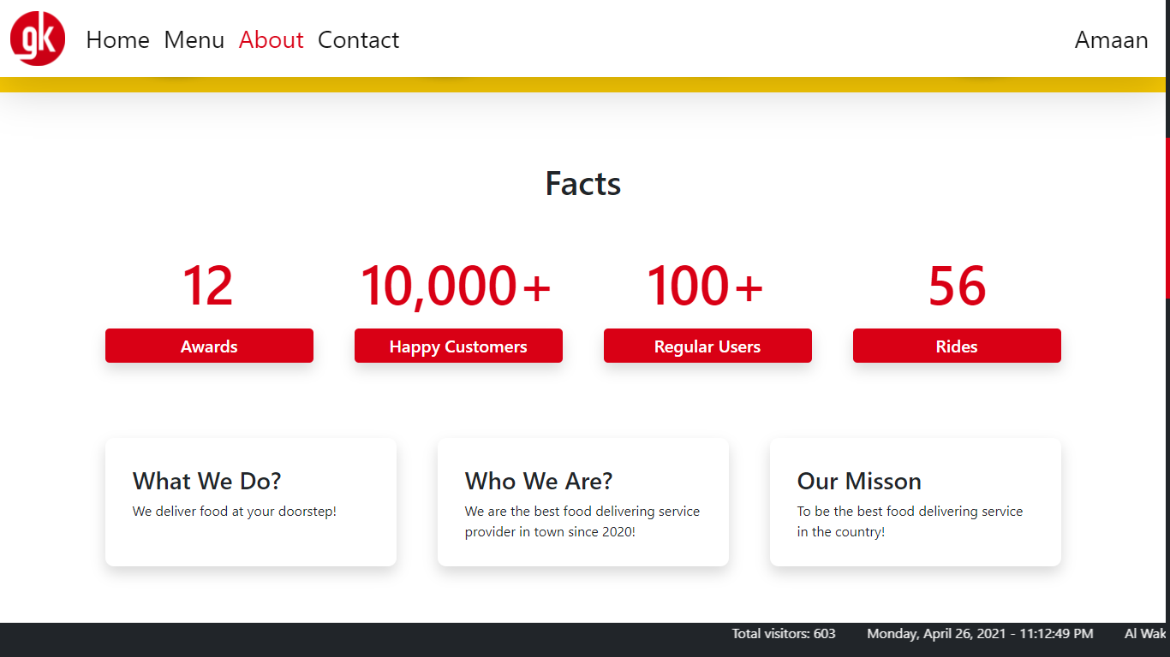

And meet our team.

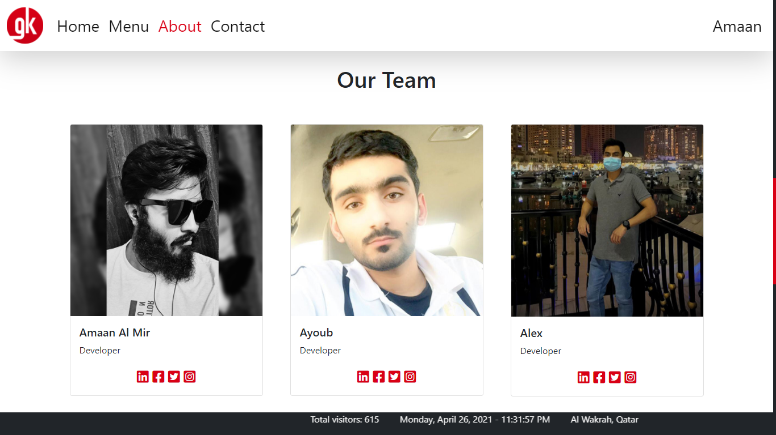

Last but not least, follow us on social media.

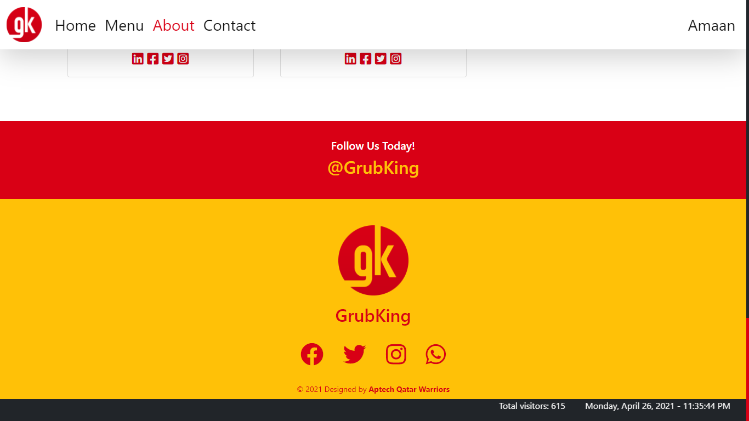

Contact Page

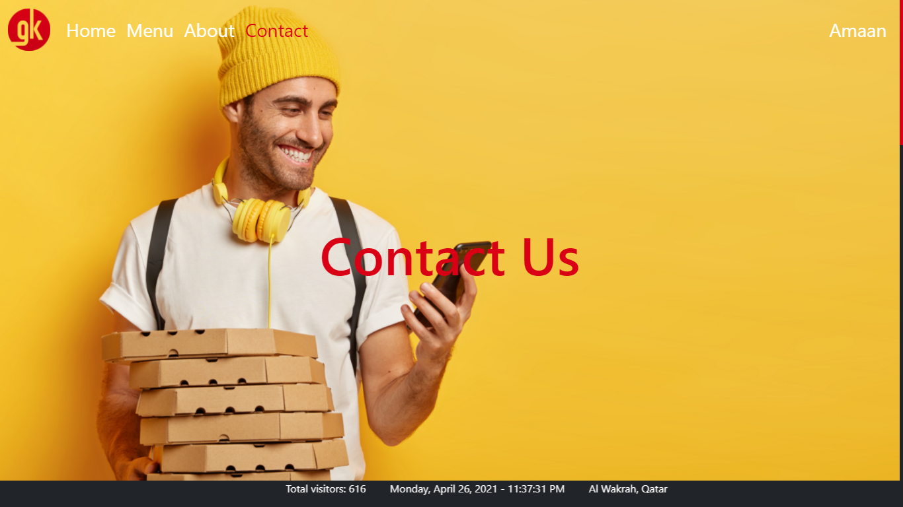

On the contact page, we have provided a Google map of our headquarter location.

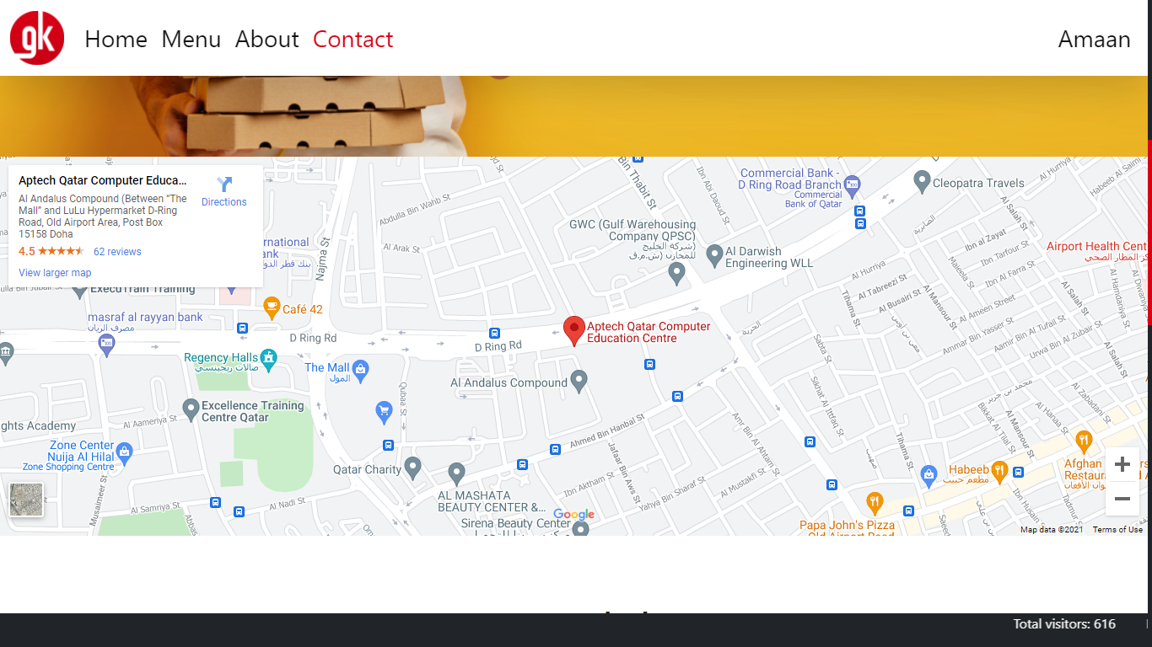

Plus, our contact details like emails, telephone and mobile numbers and our address.

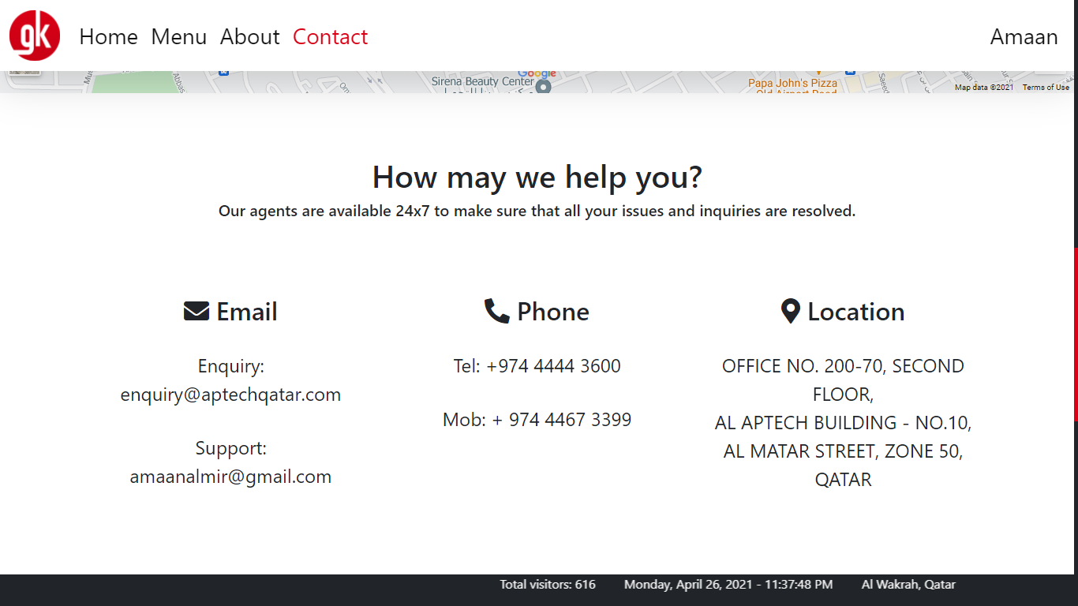

You can also send us a message or share a feedback if you like using the form feature.

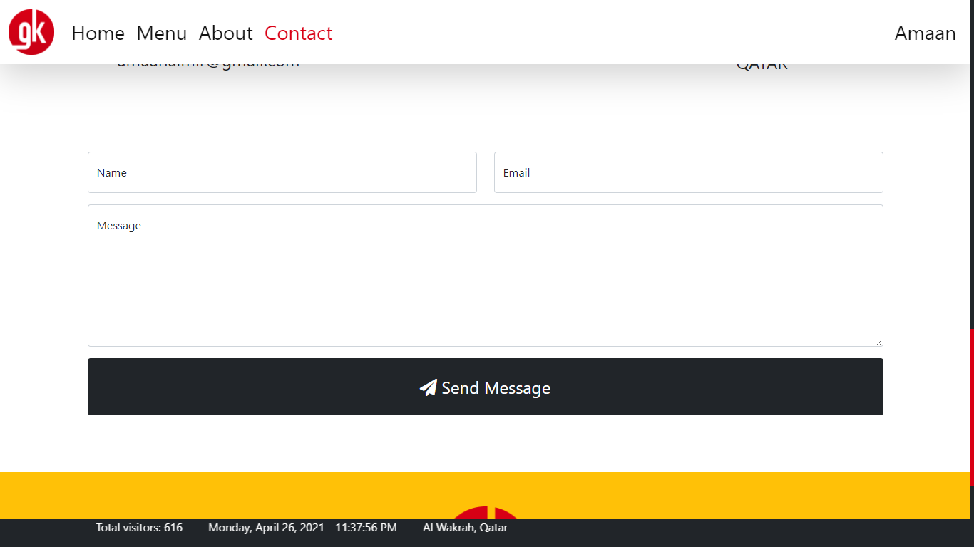

Developer Guide

This website is built with the help of three programming languages and five open-source libraries.

Programming Languages:

1. HTML5
2. CSS3
3. JavaScript

Open-Source Technologies Used:

1. Bootstrap v5.0.0-beta3
2. jQuery v3.6.0
3. Isotopes (to filter and sort Menu items)
4. Snipcart (to implement the item purchasing feature)
5. Font Awesome v5.15.3

Features:

* Latest browser compatibility
* Doesn’t need an internet connection to test the site (all required sources are locally saved.)
* Testing the site is super easy
* The whole site is user-friendly

Sofware used to write the code:

* Visual Studio Code

Source Code

HTML

[ General / Common on All Pages ]

1. The Head Tag

<head>

  <meta charset="utf-8">

  <meta content="width=device-width, initial-scale=1.0" name="viewport">

  <!-- CSS -->

  <link rel="stylesheet" href="assets/css/bootstrap.min.css">

  <link rel="stylesheet" href="assets/fontawesome/css/all.min.css">

  <link rel="preconnect" href="https://app.snipcart.com">

  <link rel="preconnect" href="https://cdn.snipcart.com">

  <link rel="stylesheet" href="https://cdn.snipcart.com/themes/v3.1.0/default/snipcart.css" />

  <link rel="stylesheet" href="assets/css/style.css">

  <!-- CSS - END -->

  <title>GrubKing</title>

  <link rel="shortcut icon" href="images/gk.png" type="image/x-icon">

</head>

1. Scrolling Ticker

<marquee class="bg-dark" behavior="scroll" direction="left">

    <p><span id="visitors"></span> <span id="scrollingTicker"></span> <span id="mylocation"></span>

    </p>

  </marquee>

1. The Navigation Bar

<nav class="navbar fixed-top navbar-expand-lg navbar-light">

    <div class="container-fluid fs-3">

      <a class="navbar-brand fs-3" href="index.html"><img src="images/gk.png"></a>

      <button class="navbar-toggler" type="button" data-bs-toggle="collapse" data-bs-target="#navmob"

        aria-controls="navmob" aria-expanded="false" aria-label="Toggle navigation">

        <span class="navbar-toggler-icon"></span>

      </button>

      <div class="collapse navbar-collapse" id="navmob">

        <div class="navbar-nav mr-auto">

          <a class="nav-link active" href="index.html">Home</a>

          <a class="nav-link" href="menu.html">Menu</a>

          <a class="nav-link" href="about.html">About</a>

          <a class="nav-link" href="contact.html">Contact</a>

        </div>

      </div>

      <div class="collapse navbar-collapse" id="navmob">

        <div class="navbar-nav ms-auto">

          <a class="nav-link" id="loginBtn" href="" data-bs-toggle="modal" data-bs-target="#userLoginPortal">Login</a>

          <li class="nav-item dropdown">

            <a class="nav-link dropdown-toggle" id="displayUser" role="button" data-bs-toggle="dropdown">Username</a>

            <ul class="dropdown-menu dropdown-menu-dark dropdown-menu-lg-end" aria-labelledby="logout">

              <a href="" class="dropdown-item" onclick="logout()">Log Out</a>

            </ul>

          </li>

        </div>

      </div>

    </div>

    </div>

  </nav>

1. User Login Forum

<div class="modal fade" id="userLoginPortal" tabindex="-1" aria-labelledby="userLoginModal" aria-hidden="true">

    <div class="modal-dialog modal-dialog-centered">

      <div class="modal-content">

        <div class="modal-header">

          <h5 class="modal-title" id="userLoginModal">Login</h5>

          <button type="button" class="btn-close" data-bs-dismiss="modal" aria-label="Close"></button>

        </div>

        <div class="modal-body">

          <form id="login-form" class="needs-validation" onsubmit="return false">

            <div class="form-floating mb-3">

              <input type="text" class="form-control" id="username" minlength="4" placeholder=" " required>

              <label for="username">Username</label>

            </div>

            <div class="form-floating mb-3">

              <input type="password" class="form-control" id="userpassword" placeholder=" ">

              <label for="userpassword">Password (optional)</label>

            </div>

            <button type="submit" class="btn btn-danger" onclick="login()">Log in</button>

          </form>

        </div>

      </div>

    </div>

  </div>

1. Welcome Modal

<div class="modal fade" id="welcomeModal" tabindex="-1" aria-labelledby="welcomeModal" aria-hidden="true">

    <div class="modal-dialog modal-dialog-centered">

      <div class="modal-content">

        <div class="modal-body text-center">

          <div class="f-modal-alert">

            <div class="f-modal-icon f-modal-success animate">

              <span class="f-modal-line f-modal-tip animateSuccessTip"></span>

              <span class="f-modal-line f-modal-long animateSuccessLong"></span>

              <div class="f-modal-placeholder"></div>

              <div class="f-modal-fix"></div>

            </div>

          </div>

          <h1>WELCOME!</h1>

          <h6>You Are Logged in!</h6>

        </div>

        <div class="modal-footer">

          <button type="button" class="btn btn-danger" data-bs-dismiss="modal">Okay!</button>

        </div>

      </div>

    </div>

  </div>

1. Footer

<footer class="bg-warning py-5">

    <div class="container">

      <img src="images/gk.png">

      <h2>GrubKing</h2>

      <div class="socialMedia">

        <a href="https://www.facebook.com/aptechqatar"><i class="fab fa-facebook fa-3x"></i></a>

        <a href="https://twitter.com/aptechqatar"><i class="fab fa-twitter fa-3x"></i></a>

        <a href="https://www.instagram.com/aptechqatar/"><i class="fab fa-instagram fa-3x"></i></a>

        <a href="https://api.whatsapp.com/send/?phone=+97433013399&text=Message+us%21"><i

            class="fab fa-whatsapp fa-3x"></i></a>

      </div>

      <span>

        &copy; 2021 Designed by <strong><span>Aptech Qatar Warriors</span></strong>

      </span>

    </div>

  </footer>

1. Script Tags

<!-- SCRIPTS -->

  <script src="assets/js/jquery.min.js"></script>

  <script src="assets/js/bootstrap.bundle.min.js"></script>

  <script src="assets/js/isotope.pkgd.min.js"></script>

  <script async src="https://cdn.snipcart.com/themes/v3.1.0/default/snipcart.js"></script>

  <div id="snipcart" data-config-modal-style="side"

    data-api-key="MGM4MzA3ZjktMGRhYS00ZjU4LTllYzMtYTYzMjFlNGJjMzA2NjM3NTQ4Mzc2OTI4Njc1MjU5" hidden></div>

  <script src="assets/js/script.js"></script>

  <!-- SCRIPTS - END -->

[ Index.html ]

Hero Section

<!--===== HERO SECTION =====-->

  <section class="hero">

    <div id="hero-carousel" class="carousel slide" data-bs-ride="carousel">

      <div class="carousel-inner">

        <div class="carousel-item active" data-bs-interval="3000">

          <img src="images/hero/hero-home-1.jpg">

        </div>

        <div class="carousel-item" data-bs-interval="5000">

          <img src="images/hero/hero-home-2.jpg">

        </div>

        <div class="carousel-item" data-bs-interval="5000">

          <img src="images/hero/hero-home-3.jpg">

        </div>

      </div>

      <button class="carousel-control-prev" type="button" data-bs-target="#hero-carousel" data-bs-slide="prev">

        <span class="carousel-control-prev-icon" aria-hidden="true"></span>

        <span class="visually-hidden">Previous</span>

      </button>

      <button class="carousel-control-next" type="button" data-bs-target="#hero-carousel" data-bs-slide="next">

        <span class="carousel-control-next-icon" aria-hidden="true"></span>

        <span class="visually-hidden">Next</span>

      </button>

    </div>

  </section>

  <!--===== HERO SECTION - END =====-->

Home Section

<!--===== HOME SECTION =====-->

  <section class="home">

    <div class="container">

      <div class="featured">

        <div class="row g-5">

          <div class="col-lg-6 align-self-center">

            <div class="featured-box">

              <h2>Try the New Crispy Chicken Sandwiches</h2>

              <p>Take a bite and you’ll find out what CrispyJuicyTender means. Whether it’s Crispy, Spicy or Deluxe,

                there’s a new sandwich for everyone.</p>

              <a class="btn btn-warning" href="menu.html">Order Now</a>

            </div>

          </div>

          <div class="col-lg-6">

            <img src="images/home/featured-1.jpg" width="100%">

          </div>

          <div class="col-lg-6">

            <img src="images/home/featured-2.jpg" width="100%">

          </div>

          <div class="col-lg-6 align-self-center text-end">

            <div class="featured-box">

              <h2>$0.99 Any Size Premium Roast Coffee or Iced Coffee*</h2>

              <p>Ice-cold or deliciously hot, get it anytime for just $0.99.</p>

              <a class="btn btn-warning" href="menu.html">Open Menu</a>

            </div>

          </div>

        </div>

      </div>

    </div>

  </section>

  <!--===== HOME SECTION - END =====-->

Promotional Advertisement on the homepage.

<div class="app">

    <div class="container">

      <div class="row">

        <div class="col-lg-6">

          <h2>Discover the new GrubKing app</h2>

          <p>Get what you need, when you need it.</p>

          <div class="row">

            <div class="col-6 col-lg-4">

              <a href="https://www.apple.com/app-store/">

                <img src="images/home/logo-appstore.svg" width="100%">

              </a>

            </div>

            <div class="col-6 col-lg-4">

              <a href="https://play.google.com/store">

                <img src="images/home/logo-playstore.svg" width="100%">

              </a>

            </div>

          </div>

        </div>

        <div class="col-lg-6">

          <img src="images/home/app.png" width="100%">

        </div>

      </div>

    </div>

  </div>

[ Menu.html ]

Hero Section

<section class="hero">

    <img src="images/hero/hero-menu.jpg">

</section>

Search Bar

<!-- MENU SECTION -->

  <section class="menu">

    <div class="container">

      <div class="row">

        <div class="col-lg-2 align-self-center">

          <img src="images/menu/menu.png" width="100%">

        </div>

        <div class="col-lg-10">

          <div class="input-group my-5">

            <input type="text" class="menu-search form-control bg-dark" placeholder="Search" autocomplete="on">

            <span class="input-group-text bg-dark"><i class="fas fa-search fa-lg"></i></span>

          </div>

        </div>

      </div>

Restaurant Filter

      <!-- RESTAURANT FILTER -->

      <div class="row g-5">

        <div class="col-lg-12">

          <div class="restaurants">

            <div class="menu-filter" data-filter-group="resturants">

              <h4>Resturants</h4>

              <div class="row g-3">

                <div class="col-lg-12 pt-3 pb-5">

                  <button type="button" class="btn btn-dark active fs-3" data-filter="*">All</button>

                </div>

                <div class="col-4 col-lg-2">

                  <button type="button" class="btn" data-filter=".mcdonalds">

                    <img src="images/menu/restaurant-logos/mcdonalds.png" />

                  </button>

                </div>

                <div class="col-4 col-lg-2">

                  <button type="button" class="btn" data-filter=".burgerking">

                    <img src="images/menu/restaurant-logos/burgerking.png" />

                  </button>

                </div>

                <div class="col-4 col-lg-2">

                  <button type="button" class="btn" data-filter=".afghanbrothers">

                    <img src="images/menu/restaurant-logos/afghanbrothers.png" />

                  </button>

                </div>

                <div class="col-4 col-lg-2">

                  <button type="button" class="btn" data-filter=".hotcold">

                    <img src="images/menu/restaurant-logos/hotncool.png" />

                  </button>

                </div>

                <div class="col-4 col-lg-2">

                  <button type="button" class="btn" data-filter=".subway">

                    <img src="images/menu/restaurant-logos/subway.png" />

                  </button>

                </div>

                <div class="col-4 col-lg-2">

                  <button type="button" class="btn" data-filter=".paprika">

                    <img src="images/menu/restaurant-logos/paprika.png" />

                  </button>

                </div>

                <div class="col-4 col-lg-2">

                  <button type="button" class="btn" data-filter=".indian">

                    <img src="images/menu/restaurant-logos/indian.png" />

                  </button>

                </div>

              </div>

            </div>

          </div>

        </div>

        <!-- RESTAURANT FILTER - END -->

Filters (Categories)

        <!-- FILTER CATEGORIES -->

        <div class="col-4 col-lg-2">

          <div class="menuFilters">

            <h4>Categories</h4>

            <div class="menu-filter btn-group-vertical" data-filter-group="cuisines">

              <button type="button" class="btn btn-dark active" data-filter="*">All</button>

              <button type="button" class="btn btn-dark" data-filter=".breakfast">Breakfast</button>

              <button type="button" class="btn btn-dark" data-filter=".lunch">Lunch</button>

              <button type="button" class="btn btn-dark" data-filter=".dinner">Dinner</button>

              <button type="button" class="btn btn-dark" data-filter=".american">American</button>

              <button type="button" class="btn btn-dark" data-filter=".arabian">Arabian</button>

              <button type="button" class="btn btn-dark" data-filter=".indian">Indian</button>

              <button type="button" class="btn btn-dark" data-filter=".italian">Italian</button>

              <button type="button" class="btn btn-dark" data-filter=".veg">Vegetarian</button>

              <button type="button" class="btn btn-dark" data-filter=".nonveg">Non-Vegetarian</button>

              <button type="button" class="btn btn-dark" data-filter=".chicken">Chicken</button>

              <button type="button" class="btn btn-dark" data-filter=".beef">Beef</button>

              <button type="button" class="btn btn-dark" data-filter=".fish">Fish</button>

              <button type="button" class="btn btn-dark" data-filter=".lamb">Lamb</button>

              <button type="button" class="btn btn-dark" data-filter=".turkey">Turkey</button>

              <button type="button" class="btn btn-dark" data-filter=".burger">Burger</button>

              <button type="button" class="btn btn-dark" data-filter=".sandwich">Sandwich</button>

              <button type="button" class="btn btn-dark" data-filter=".drink">Beverages</button>

              <button type="button" class="btn btn-dark" data-filter=".icecream">Ice cream</button>

            </div>

          </div>

        </div>

        <!-- FILTER CATEGORIES - END -->

One example of a food item.

<div class="col-8 col-lg-10">

          <div class="row menu-card g-3">

            <div class="col-lg-4 menu-item american nonveg mcdonalds beef">

              <div class="card">

                <div class="img-box">

                  <img src="images/menu/McDonalds/mcdonalds-16.jpg" class="card-img-top">

                </div>

                <div class="card-body">

                  <h5>McRoyale Large Meal</h5>

                  <h6 class="text-muted">McDonalds</h6>

                  <p>Large Beef Burger</p>

                  <h6>Price: <span class="price">$12.00</span></h6>

                  <button class="snipcart-add-item btn btn-dark" data-item-id="mcdonalds-16" data-item-price="12.00"

                    data-item-url="mcdonalds-16" data-item-description="Large Beef Burger"

                    data-item-image="images/menu/McDonalds/mcdonalds-16.jpg" data-item-name="McRoyale Large Meal">Add

                    to cart</button>

                </div>

              </div>

            </div>

[ about.html ]

About Section (Facts)

 <!--===== ABOUT SECTION =====-->

  <section class="about">

    <div class="container">

      <div class="facts">

        <h1>Facts</h1>

        <div class="row g-5">

          <div class="col-md-6 col-lg-3">

            <h2>12</h2>

            <h5>Awards</h5>

          </div>

          <div class="col-md-6 col-lg-3">

            <h2>10,000+</h2>

            <h5>Happy Customers</h5>

          </div>

          <div class="col-md-6 col-lg-3">

            <h2>100+</h2>

            <h5>Regular Users</h5>

          </div>

          <div class="col-md-6 col-lg-3">

            <h2>56</h2>

            <h5>Rides</h5>

          </div>

        </div>

      </div>

      <div class="row g-5">

        <div class="col-lg-4">

          <div class="fact2-box">

            <h3>What We Do?</h3>

            <p>We deliver food at your doorstep!</p>

          </div>

        </div>

        <div class="col-lg-4">

          <div class="fact2-box">

            <h3>Who We Are?</h3>

            <p>We are the best food delivering service provider in town since 2020!</p>

          </div>

        </div>

        <div class="col-lg-4">

          <div class="fact2-box">

            <h3>Our Misson</h3>

            <p>To be the best food delivering service in the country!</p>

          </div>

        </div>

      </div>

Teams

<div class="team">

        <div class="row g-5">

          <h1>Our Team</h1>

          <div class="col-lg-4">

            <div class="card">

              <img src="images/about/almir.jpg" class="card-img-top">

              <div class="card-body">

                <h5 class="card-title">Amaan Al Mir</h5>

                <p class="card-text">Developer</p>

                <div class="profile-links">

                  <a href=""><i class="fab fa-linkedin"></i></a>

                  <a href=""><i class="fab fa-facebook-square"></i></a>

                  <a href=""><i class="fab fa-twitter-square"></i></a>

                  <a href=""><i class="fab fa-instagram-square"></i></a>

                </div>

              </div>

            </div>

          </div>

          <div class="col-lg-4">

            <div class="card">

              <img src="images/about/ayoub.jpg" class="card-img-top">

              <div class="card-body">

                <h5 class="card-title">Ayoub</h5>

                <p class="card-text">Developer</p>

                <div class="profile-links">

                  <a href=""><i class="fab fa-linkedin"></i></a>

                  <a href=""><i class="fab fa-facebook-square"></i></a>

                  <a href=""><i class="fab fa-twitter-square"></i></a>

                  <a href=""><i class="fab fa-instagram-square"></i></a>

                </div>

              </div>

            </div>

          </div>

          <div class="col-lg-4">

            <div class="card">

              <img src="images/about/alex.jpg" class="card-img-top">

              <div class="card-body">

                <h5 class="card-title">Alex</h5>

                <p class="card-text">Developer</p>

                <div class="profile-links">

                  <a href=""><i class="fab fa-linkedin"></i></a>

                  <a href=""><i class="fab fa-facebook-square"></i></a>

                  <a href=""><i class="fab fa-twitter-square"></i></a>

                  <a href=""><i class="fab fa-instagram-square"></i></a>

                </div>

              </div>

            </div>

          </div>

          <div class="col-lg-4">

            <div class="card">

              <img src="images/avatar.jpg" class="card-img-top">

              <div class="card-body">

                <h5 class="card-title">Daffa</h5>

                <p class="card-text">Developer</p>

                <div class="profile-links">

                  <a href=""><i class="fab fa-linkedin"></i></a>

                  <a href=""><i class="fab fa-facebook-square"></i></a>

                  <a href=""><i class="fab fa-twitter-square"></i></a>

                  <a href=""><i class="fab fa-instagram-square"></i></a>

                </div>

              </div>

            </div>

          </div>

          <div class="col-lg-4">

            <div class="card">

              <img src="images/about/khalifa.jpg" class="card-img-top">

              <div class="card-body">

                <h5 class="card-title">Khalifa</h5>

                <p class="card-text">Developer</p>

                <div class="profile-links">

                  <a href=""><i class="fab fa-linkedin"></i></a>

                  <a href=""><i class="fab fa-facebook-square"></i></a>

                  <a href=""><i class="fab fa-twitter-square"></i></a>

                  <a href=""><i class="fab fa-instagram-square"></i></a>

                </div>

              </div>

            </div>

          </div>

        </div>

      </div>

  </section>

  <!--===== ABOUT SECTION - END =====-->

[ About.html footer ]

  <div class="about-foot">

    <h5>Follow Us Today!</h5>

    <h2 class="text-warning">@GrubKing</h2>

  </div>

[ contact.html ]

Google Map

Embedded using iframe

<!-- GOOGLE MAP LOCATION -->

    <div class="map">

      <iframe

        src="https://www.google.com/maps/embed?pb=!1m18!1m12!1m3!1d3608.486910686228!2d51.54063441544951!3d25.25420103558171!2m3!1f0!2f0!3f0!3m2!1i1024!2i768!4f13.1!3m3!1m2!1s0x3e45cf910e08feb3%3A0xd4aa7a447cd2c7d0!2sAptech%20Qatar%20Computer%20Education%20Centre!5e0!3m2!1sen!2sqa!4v1617927551802!5m2!1sen!2sqa"

        width="100%" height="450" style="border:0;" allowfullscreen="" loading="lazy"></iframe>

    </div>

    <!-- GOOGLE MAP LOCATION - END -->

Contact details

<div class="container text-center">

      <div class="my-5">

        <h1>How may we help you?</h1>

        <h5>Our agents are available 24x7 to make sure that all your issues and inquiries are resolved.</h5>

      </div>

      <div class="row g-5 my-5">

        <div class="col-lg-4">

          <div class="email">

            <h2><i class="fas fa-envelope"></i> Email</h2>

            <p>Enquiry: enquiry@aptechqatar.com</p>

            <p>Support: amaanalmir@gmail.com</p>

            </p>

          </div>

        </div>

        <div class="col-lg-4">

          <div class="phone">

            <h2><i class="fas fa-phone-alt"></i> Phone</h2>

            <p>Tel: +974 4444 3600</p>

            <p>Mob: + 974 4467 3399</p>

          </div>

        </div>

        <div class="col-lg-4">

          <div class="location">

            <h2><i class="fas fa-map-marker-alt"></i> Location</h2>

            <p>OFFICE NO. 200-70, SECOND FLOOR,<br>

              AL APTECH BUILDING - NO.10,<br>

              AL MATAR STREET, ZONE 50,<br>

              QATAR</p>

          </div>

        </div>

      </div>

Contact Forum

<!-- CONTACT FORM -->

      <form class="needs-validation">

        <div class="row">

          <div class="col-md">

            <div class="form-floating mb-3">

              <input type="text" class="form-control" id="username" minlength="4" placeholder=" " required>

              <label for="username">Name</label>

            </div>

          </div>

          <div class="col-md">

            <div class="form-floating mb-3">

              <input type="email" class="form-control" id="useremail" placeholder=" " required>

              <label for="useremail">Email</label>

            </div>

          </div>

        </div>

        <div class="form-floating mb-3">

          <textarea class="form-control" id="floatingTextarea2" minlength="15" placeholder=" " style="height: 200px"

            required></textarea>

          <label for="floatingTextarea2">Message</label>

        </div>

        <button class="btn btn-dark" type="submit"><i class="fas fa-paper-plane"></i> Send Message</button>

      </form>

      <!-- CONTACT FORM - END -->

    </div>

  </section>

  <!--===== CONTACT SECTION- END =====-->

That was the end of HTML coding.

CCS

/*==================================

  # GENERAL

  ==================================*/

::-webkit-scrollbar {

  width: 5px;

}

::-webkit-scrollbar-thumb {

  background: #D90015;

}

::-webkit-scrollbar-track {

  background: #212529;

}

a {

  color: #D90015;

}

a:hover {

  color: #111;

}

/*==================================

  # WELCOME BOX

  ==================================*/

.f-modal-alert .f-modal-icon {

  border-radius: 50%;

  border: 4px solid gray;

  box-sizing: content-box;

  height: 80px;

  margin: 20px auto;

  padding: 0;

  position: relative;

  width: 80px;

}

.f-modal-alert .f-modal-icon.f-modal-success,

.f-modal-alert .f-modal-icon.f-modal-error {

  border-color: #A5DC86;

}

.f-modal-alert .f-modal-icon.f-modal-success:after,

.f-modal-alert .f-modal-icon.f-modal-success:before,

.f-modal-alert .f-modal-icon.f-modal-error:after,

.f-modal-alert .f-modal-icon.f-modal-error:before {

  background: #fff;

  content: "";

  height: 120px;

  position: absolute;

  transform: rotate(45deg);

  width: 60px;

}

.f-modal-alert .f-modal-icon.f-modal-success:before,

.f-modal-alert .f-modal-icon.f-modal-error:before {

  border-radius: 120px 0 0 120px;

  left: -33px;

  top: -7px;

  transform-origin: 60px 60px;

  transform: rotate(-45deg);

}

.f-modal-alert .f-modal-icon.f-modal-success:after,

.f-modal-alert .f-modal-icon.f-modal-error:after {

  border-radius: 0 120px 120px 0;

  left: 30px;

  top: -11px;

  transform-origin: 0 60px;

  transform: rotate(-45deg);

}

.f-modal-alert .f-modal-icon.f-modal-success .f-modal-placeholder,

.f-modal-alert .f-modal-icon.f-modal-error .f-modal-placeholder {

  border-radius: 50%;

  border: 4px solid rgba(165, 220, 134, 0.2);

  box-sizing: content-box;

  height: 80px;

  left: -4px;

  position: absolute;

  top: -4px;

  width: 80px;

  z-index: 2;

}

.f-modal-alert .f-modal-icon.f-modal-success .f-modal-fix,

.f-modal-alert .f-modal-icon.f-modal-error .f-modal-fix {

  background-color: #fff;

  height: 90px;

  left: 28px;

  position: absolute;

  top: 8px;

  transform: rotate(-45deg);

  width: 5px;

  z-index: 1;

}

.f-modal-alert .f-modal-icon.f-modal-success .f-modal-line,

.f-modal-alert .f-modal-icon.f-modal-error .f-modal-line {

  background-color: #A5DC86;

  border-radius: 2px;

  display: block;

  height: 5px;

  position: absolute;

  z-index: 2;

}

.f-modal-alert .f-modal-icon.f-modal-success .f-modal-line.f-modal-tip,

.f-modal-alert .f-modal-icon.f-modal-error .f-modal-line.f-modal-tip {

  left: 14px;

  top: 46px;

  transform: rotate(45deg);

  width: 25px;

}

.f-modal-alert .f-modal-icon.f-modal-success .f-modal-line.f-modal-long,

.f-modal-alert .f-modal-icon.f-modal-error .f-modal-line.f-modal-long {

  right: 8px;

  top: 38px;

  transform: rotate(-45deg);

  width: 47px;

}

.animateSuccessTip {

  -webkit-animation: animateSuccessTip 0.75s;

  animation: animateSuccessTip 0.75s;

}

.animateSuccessLong {

  -webkit-animation: animateSuccessLong 0.75s;

  animation: animateSuccessLong 0.75s;

}

.f-modal-icon.f-modal-success.animate:after {

  -webkit-animation: rotatePlaceholder 4.25s ease-in;

  animation: rotatePlaceholder 4.25s ease-in;

}

@-webkit-keyframes animateSuccessTip {

  0%,

  54% {

    width: 0;

    left: 1px;

    top: 19px;

  }

  70% {

    width: 50px;

    left: -8px;

    top: 37px;

  }

  84% {

    width: 17px;

    left: 21px;

    top: 48px;

  }

  100% {

    width: 25px;

    left: 14px;

    top: 45px;

  }

}

@keyframes animateSuccessTip {

  0%,

  54% {

    width: 0;

    left: 1px;

    top: 19px;

  }

  70% {

    width: 50px;

    left: -8px;

    top: 37px;

  }

  84% {

    width: 17px;

    left: 21px;

    top: 48px;

  }

  100% {

    width: 25px;

    left: 14px;

    top: 45px;

  }

}

@-webkit-keyframes animateSuccessLong {

  0%,

  65% {

    width: 0;

    right: 46px;

    top: 54px;

  }

  84% {

    width: 55px;

    right: 0;

    top: 35px;

  }

  100% {

    width: 47px;

    right: 8px;

    top: 38px;

  }

}

@keyframes animateSuccessLong {

  0%,

  65% {

    width: 0;

    right: 46px;

    top: 54px;

  }

  84% {

    width: 55px;

    right: 0;

    top: 35px;

  }

  100% {

    width: 47px;

    right: 8px;

    top: 38px;

  }

}

@-webkit-keyframes rotatePlaceholder {

  0%,

  5% {

    transform: rotate(-45deg);

  }

  100%,

  12% {

    transform: rotate(-405deg);

  }

}

@keyframes rotatePlaceholder {

  0%,

  5% {

    transform: rotate(-45deg);

  }

  100%,

  12% {

    transform: rotate(-405deg);

  }

}

/*==================================

  # NAVIGATION BAR

  ==================================*/

.navbar {

  transition: .5s all ease-in-out;

}

.navbar img {

  width: 4rem;

}

.nav-link {

  color: #fff !important;

}

.nav-link:hover {

  color: #D90015 !important;

}

.nav-link.active {

  color: #D90015 !important;

}

.navscroll {

  background: #fff;

  box-shadow: 0 1rem 3rem rgba(0, 0, 0, .175)

}

.navscroll .nav-link {

  color: #111 !important;

}

.navscroll .nav-link.active {

  color: #D90015 !important;

}

.navbar .dropdown-toggle::after {

  display: none;

}

#displayUser {

  display: none;

}

.dropdown-item:focus {

  background: #D90015 !important;

}

/*==================================

  # HERO SECTION

  ==================================*/

.hero {

  width: 100%;

  height: 100%;

}

.hero img {

  width: 100%;

  height: 100%;

  object-fit: cover;

}

.hero h1 {

  color: #D90015;

  position: absolute;

  top: 50%;

  left: 50%;

  transform: translate(-50%, -50%);

  font-size: 5rem;

}

/*==================================

  # HOME PAGE

  ==================================*/

.home {

  margin-top: 5rem;

  margin-bottom: 10rem;

}

.home .btn {

  font-size: larger;

  border: none !important;

}

.home .btn:hover {

  background: #D90015;

  color: #fff;

}

/*==================================

  # MENU / PRODUCTS PAGE

  ==================================*/

.menu {

  margin: 5rem auto;

}

.menu-search {

  font-size: larger;

  border: none;

  box-shadow: none !important;

  color: #fff !important;

}

.input-group-text {

  border: none;

  color: #D90015;

}

.restaurants {

  text-align: center;

}

.restaurants .menu-filter .btn.active[data-filter="*"] {

  background: #D90015;

}

.restaurants .menu-filter .btn.active {

  background: blanchedalmond;

}

.restaurants img {

  width: 100px;

}

.restaurants .btn:hover img {

  transform: scale(1.1);

}

.menuFilters {

  top: 7rem;

}

.menuFilters h4 {

  text-align: center;

}

.menu-filter {

  width: 100%;

}

.menu-filter .btn {

  border: none;

  box-shadow: none !important;

}

.menu-filter .btn.active {

  background: #D90015;

}

.menu-card .btn {

  margin-top: 1rem;

  border: none;

  box-shadow: none !important;

}

.menu-card .btn:hover {

  background: #D90015;

}

.menu-card .price {

  color: #D90015;

}

.menu-card .card .img-box {

  overflow: hidden;

}

.menu-card .card .img-box img {

  transition: .3s all ease-out;

}

.menu-card .card img:hover {

  transform: scale(1.5);

}

/*==================================

  # SNIPCART

  ==================================*/

.snipcart-modal__container {

  z-index: 99999;

}

/*==================================

  # ABOUT PAGE

  ==================================*/

.about {

  margin: 5rem auto;

}

.facts {

  text-align: center;

  margin-bottom: 5rem;

}

.facts div div:hover {

  transform: scale(1.05);

}

.facts h2 {

  color: #D90015;

  font-size: 4rem;

  margin-top: 3rem;

  margin-bottom: 1rem;

}

.facts h5 {

  background: #D90015;

  padding: .5rem 1rem;

  border-radius: 5px;

  color: #fff;

  box-shadow: 0 .5rem 1rem rgba(0, 0, 0, .15);

}

.fact2-box {

  box-shadow: 0 .5rem 1rem rgba(0, 0, 0, .15);

  border-radius: 10px;

  align-items: center;

  height: 150px;

  padding: 2rem;

}

.team {

  margin-top: 5rem;

}

.team h1 {

  text-align: center;

}

.team .profile-links {

  text-align: center;

  font-size: 1.5rem;

}

.about-foot {

  color: #fff;

  text-align: center;

  padding: 2rem 0;

  background: #D90015;

}

/*==================================

  # CONTACT PAGE

  ==================================*/

.contact .container {

  margin-top: 5rem;

}

.email p,

.phone p,

.location p {

  margin-top: 2rem;

  font-size: x-large;

}

.contact form {

  margin: 5rem auto;

}

.contact form .btn {

  width: 100%;

  height: 5rem;

  font-size: x-large;

  border: none;

}

.contact form input:focus,

.contact form textarea:focus {

  border-color: #D90015 !important;

  box-shadow: none !important;

}

.contact form .btn:hover {

  background: #D90015;

  border: none;

  color: #FFF;

}

/*==================================

  # SCROLLING TICKER & FOOTER

  ==================================*/

marquee {

  color: #fff;

  position: fixed;

  bottom: 0;

  z-index: 1;

}

marquee span {

  padding: 0 1rem;

}

footer {

  color: #D90015;

  font-size: 14px;

  text-align: center;

}

footer img {

  width: 8rem;

  margin-bottom: 1rem;

}

.socialMedia {

  margin: 2rem 0;

}

.socialMedia a {

  margin: 0 1rem;

}

/*==================================

  # RESPONSIVE SETTINGS

  ==================================*/

@media (max-width:990px) {

  .navbar {

    background: #fff;

  }

  .nav-link {

    color: #111 !important;

  }

  .hero {

    padding-top: 85px;

  }

  .hero img {

    height: auto;

  }

}

That was the end of CSS coding.

JavaScript

1. The Scrolling Ticker
   1. Visitors Count

// ==================================================

// SCROLLING TICKER AT THE BOTTOM

// ==================================================

window.addEventListener('load', function () {

  var visitors = document.getElementById("visitors");

  var counter = 1

  var storedCounter = localStorage.getItem("count");

  count = parseInt(storedCounter)

  if (count) {

    localStorage.setItem("count", count + 1)

    visitors.innerHTML = "Total visitors: " + count

  } else {

    localStorage.setItem("count", counter)

    visitors.innerHTML = "Total visitors: " + counter

  }

})

This code shows the number of times you have visited the site which you can find at the bottom of the screen.

* 1. Date and Time

function scrollingTicker() {

  var cd = new Date()

  var days = ["Sunday", "Monday", "Tuesday", "Wednesday", "Thursday", "Friday", "Saturday"];

  day = days[cd.getDay()];

  var months = ["January", "February", "March", "April", "May", "June", "July", "August", "September", "October", "November", "December"];

  var month = months[cd.getMonth()];

  var date = cd.getDate()

  var year = cd.getFullYear()

  var ampm = cd.getHours() >= 12 ? ' PM' : ' AM';

  hours = cd.getHours() % 12;

  hours = hours ? hours : 12;

  hours = hours.toString().length == 1 ? 0 + hours.toString() : hours;

  var minutes = cd.getMinutes().toString()

  minutes = minutes.length == 1 ? 0 + minutes : minutes;

  var seconds = cd.getSeconds().toString()

  seconds = seconds.length == 1 ? 0 + seconds : seconds;

  var currentDate = day + ", " + month + " " + date + ", " + year;

  currentTime = " - " + hours + ":" + minutes + ":" + seconds + " " + ampm;

  document.getElementById('scrollingTicker').innerHTML = currentDate + currentTime;

}

setInterval(scrollingTicker, 1000);

This code shows the live date and time.

* 1. Current Location

const Http = new XMLHttpRequest();

window.addEventListener("load", function () {

  console.log("getLocation Called");

  var bdcApi = "https://api.bigdatacloud.net/data/reverse-geocode-client"

  navigator.geolocation.getCurrentPosition(

    (position) => {

      bdcApi = bdcApi +

        "?latitude=" + position.coords.latitude +

        "&longitude=" + position.coords.longitude +

        "&localityLanguage=en";

      getApi(bdcApi);

    },

    (err) => {

      getApi(bdcApi);

    }, {

      enableHighAccuracy: true,

      timeout: 5000,

      maximumAge: 0

    });

})

function getApi(bdcApi) {

  Http.open("GET", bdcApi);

  Http.send();

  Http.onreadystatechange = function () {

    if (this.readyState == 4 && this.status == 200) {

      const results = JSON.parse(this.responseText);

      var city = results.city

      var country = results.countryName

      document.getElementById("mylocation").innerHTML = city + ", " + country

    }

  };

}

This code displays the user’s current location.

1. Navbar Scroll Effect

// ==================================================

// NAVBAR CHANGE ON SCROLL

// ==================================================

window.addEventListener('scroll', function () {

  var nav = document.querySelector('nav');

  var windowPosition = window.pageYOffset > 0;

  nav.classList.toggle('navscroll', windowPosition);

})

This function changes the navigation bar’s background color on scroll.

1. User Login Function

// ==================================================

// USER PORTAL

// ==================================================

function login() {

  username = document.getElementById("username").value;

  if (username.length >= 4) {

    localStorage.setItem("user", JSON.stringify(username));

    var storedUser = localStorage.getItem("user");

    var user = JSON.parse(storedUser);

    loginBtn = document.getElementById("loginBtn")

    userBtn = document.getElementById("displayUser")

    loginBtn.style.display = "none"

    userBtn.style.display = "block"

    userBtn.innerHTML = user

    $("#userLoginPortal").modal("hide")

    $("#welcomeModal").modal("show")

  }

}

The “login” function reads the user input from the user login form and displays their input on the top right corner of the screen, on the navigation bar.

The login function used the browser’s localstorage feature to store the user’s name.

window.addEventListener('load', function () {

  var storedUser = localStorage.getItem("user");

  var user = JSON.parse(storedUser);

  if (user) {

    loginBtn = document.getElementById("loginBtn")

    userBtn = document.getElementById("displayUser")

    loginBtn.style.display = "none"

    userBtn.style.display = "block"

    userBtn.innerHTML = user

  } else {

    $("#userLoginPortal").modal("show")

  }

})

As shows in the above code, if the user reloads or moves to another page, this function automatically pick the stored user’s name and display on the site.

function logout() {

  localStorage.removeItem("user");

  loginBtn = document.getElementById("loginBtn")

  userBtn = document.getElementById("displayUser")

  loginBtn.style.display = "block"

  userBtn.style.display = "none"

}

The logout function simply removes the stored user’s data and display the login button back on all pages.

Menu Filter

[ Note: The function uses the open-source library, Isotopes. ]

// ==================================================

// MENU FILTERTING

// ==================================================

var buttonFilters = {};

var buttonFilter;

var qsRegex;

var menu = $('.menu-card').isotope({

  itemSelector: '.menu-item',

  filter: function () {

    var $this = $(this);

    var searchResult = qsRegex ? $this.text().match(qsRegex) : true;

    var buttonResult = buttonFilter ? $this.is(buttonFilter) : true;

    return searchResult && buttonResult;

  },

});

$('.menu-filter').on('click', '.btn', function () {

  var $this = $(this);

  var $buttonGroup = $this.parents('.menu-filter');

  var filterGroup = $buttonGroup.attr('data-filter-group');

  buttonFilters[filterGroup] = $this.attr('data-filter');

  buttonFilter = concatValues(buttonFilters);

  menu.isotope();

});

var $quicksearch = $('.menu-search').keyup(debounce(function () {

  qsRegex = new RegExp($quicksearch.val(), 'gi');

  menu.isotope();

}));

$('.menu-filter').each(function (i, buttonGroup) {

  var $buttonGroup = $(buttonGroup);

  $buttonGroup.on('click', 'button', function () {

    $buttonGroup.find('.active').removeClass('active');

    $(this).addClass('active');

  });

});

White space

function concatValues(obj) {

  var value = '';

  for (var prop in obj) {

    value += obj[prop];

  }

  return value;

}

function debounce(fn, threshold) {

  var timeout;

  threshold = threshold || 100;

  return function debounced() {

    clearTimeout(timeout);

    var args = arguments;

    var _this = this;

    function delayed() {

      fn.apply(_this, args);

    }

    timeout = setTimeout(delayed, threshold);

  };

}

That was the end of custom Javascript coding.

THANK YOU!

Aptech Qatar Warriors